**Program: 1**

**Aim:** Write a Java program that prompts the user for an integer and then prints out all prime numbers up to that. Integer.

**Code:**

importjava.util.*;

classPrimeUpTo

{

public static void main(String arg[])

{ Scannersc=new Scanner(System.in);

System.out.print("enter a number: ");

int n=sc.nextInt();

for(int j=1;j<=n;j++)

{ int count=0;

for(inti=1;i<=j;i++)

if(j%i==0)

count++;

if(count==2)

System.out.print(j+" ");

}

}

}

**Output:**

enter a number**:** 10

##### 2 3 5 7

**Program: 2**

**Aim:** Write a Java program that checks whether a given string is a palindrome or not. Ex: MADAM is a palindrome.

**Code:**

importjava.util.*;

classPalindrome

{

public static void main(String arg[])

{ Scanner s=new Scanner(System.in);

System.out.print("Enter a String: ");

String s1=s.next();

String s2=new String();

int n=s1.length();

for(inti=n-1;i>=0;i--)

s2=s2+ s1.charAt(i);

if(s1.equals(s2)==true)

System.out.println("String is Palindrome");

else

System.out.println("string is not a Palindrome");

}

}

**Output:**

Enter a String: MADAM

String is Palindrome

**Program: 3**

**Aim:** Write a Java program for sorting a given list of names in ascending order.

**Code:**

importjava.util.*;

class test{

public static void main(String arg[]){

Scanner scan=new Scanner(System.in);

System.out.println("Enter number of String");

int n=scan.nextInt();

String arr[]=new String[n];

System.out.println("Enter String's");

for(inti=0;i<n;i++)

arr[i]=scan.next();

System.out.println("Given String's are");

for(inti=0;i<n;i++)

System.out.print(arr[i]+" ");

for(inti=0;i<n;i++)

{

for(int j=0;j<n-i-1;j++)

{

if(arr[j].compareTo(arr[j+1])>0)

{

String tmp=arr[j];

arr[j]=arr[j+1];

arr[j+1]=tmp;

}

}

}

System.out.println("\nGiven String's after sorting");

for(inti=0;i<n;i++)

System.out.print(arr[i]+" ");}}

**Output:**

Enter number of String

3

Enter String's

ccc

aaa

bbb

Given String's are

cccaaabbb

Given String's after sorting

aaabbb ccc

**Program:4**

**Aim:** Write a Java Program that reads a line of integers, and then displays each integer, and the sum of all the integers (use StringTokenizer class).

**Code:**

**import**java.util.*;

**publicclass**StringToken

{

**public static void** main(String args[])

{

String s="10,20,30,40,50";

**int** sum=0;

StringTokenizer a=**new**StringTokenizer(s,",",**false**);

System.***out***.println("integers are ");

**while**(a.hasMoreTokens())

{

**int** b=Integer.*parseInt*(a.nextToken());

sum=sum+b;

System.***out***.println(" "+b);

}

System.***out***.println("sum of integers is "+sum);

}

}

**Output:**

integers are

10

20

30

40

50

sum of integers is 150

**Program: 5**

**Aim:** Write a Java program that reads a file and displays a file and displays the file on the screen, with a line number before each line.

**Code:**

**import** java.io.*;

**publicclass**FileDisplayLines {

**publicstaticvoid** main(String[] args) **throws**IOException{

BufferedReaderbr=**new**BufferedReader(**new**InputStreamReader(System.***in***));

String fname;

System.***out***.print("Enter File Name to Open (with extension like file.txt) : ");

fname = br.readLine();

String line = **null**;

**try**

{

FileReaderfileReader = **new**FileReader(fname);

BufferedReaderbufferedReader = **new**BufferedReader(fileReader);

**int** number=1;

**while**((line = bufferedReader.readLine()) != **null**)

{ System.***out***.print(number+": ");

System.***out***.println(line);number++;

}

bufferedReader.close();

}

**catch**(IOException ex)

{

System.***out***.println("Error reading file named '" + fname + "'");

}

}

}

**Output:**

Enter File Name to Open (with extension like file.txt) : a.txt

1: this is my first files program

2: in java

3: programming language.

**Program: 6**

**Aim:** Write a Java program that displays the number of characters, lines and words in a text file.

**Code:**

1. import java.io.*;
2. import java.util.StringTokenizer;
3. public class FileWordLineCount {
4. public static void main(String[] args) throws IOException{
5. String fname1;
6. intchar_count=0,word_count=0,line_count=0;
7. StringTokenizerst;
8. BufferedReaderbuf=new BufferedReader(new InputStreamReader(System.in));
9. System.out.print("Enter filename : ");
10. fname1=buf.readLine();
11. buf=new BufferedReader(new FileReader(fname1));
12. while((fname1=buf.readLine())!=null)
13. {
14. line_count++;
15. st=new StringTokenizer(fname1," ,;:.");
16. while(st.hasMoreTokens())
17. {
18. word_count++;
19. fname1=st.nextToken();
20. char_count+=fname1.length();
21. }
22. }
23. System.out.println("Character Count : "+char_count);
24. System.out.println("Word Count : "+word_count);
25. System.out.println("Line Count : "+line_count);
26. buf.close();
27. }
28. }

**Output:**

Enter filename : a.txt

Character Count : 50

Word Count : 10

Line Count : 3

**Program: 7**

**Aim:** Write a Java program for creating multiple threads using Thread class.

**Code:**

**Class** ThreadClassDemo**extends**Thread{

**publicvoid** run(){

System.***out***.println("thread is running...");

}

**publicstaticvoid** main(String args[]){

ThreadClassDemo t1=new ThreadClassDemo();

t1.start();

}

1. }
2. output:
3. thread is running...
4. **Aim:** Write a Java program for creating multiple threads using Runnable interface.

**class**ThreadRunnableDemo**implements** Runnable{

**publicvoid** run(){

System.***out***.println("thread is running...");

}

**publicstaticvoid** main(String args[]){

ThreadRunnableDemo m1=**new**ThreadRunnableDemo();

Thread t1=new Thread(m1);

t1.start();

}

1. }
2. **Output:**
3. thread is running...
4. **Program: 8**
5. **Aim:** Write a Java program that illustrates how run time polymorphism is achieved.

**Code:**

class Bike{

 void run(){System.out.println("running");}

1. }
2. class Splender extends Bike{
3. void run(){System.out.println("running safely with 60km");}
5. public static void main(String args[]){
6. Bike b = new Splender();//upcasting
7. b.run();
8. }
9. }
10. **output:**
11. running safely with 60km.

**program 9: radhansuresh@**

1. **Aim:** Write a java program that illustrates the following
2. a) Creation of simple package.

package pack1;

public class B

{

intm,n;

public B()

{

m=100;

n=200;

}

public void dispB()

{

System.out.println("In class B");

System.out.println(“m:”+m+”n:”+n);

}

}

demopack.java

import pack1.*;

classdemopack

{

public static void main(String args[])

{

A o1=new A();

B o2=new B();

O1.dispA();

o2.dispB();

}

}

1. b) Accessing a package.
2. **Program: 10**
3. package pack1;
4. public class A
5. {
6. intx,y;
7. public A()
8. {
9. x=10;
10. y=100;
11. }
12. public void dispA()
13. {
14. System.out.println("In class A");
15. System.out.println(“x:”+x+”y:”+y);
16. }
17. }
18. **output:**
19. In class A
20. x:10y:100
21. In class B
22. m:100n:200
23. **c) Aim:** Write a Java program that Implements interfaces concept.
24. **publicinterface**interfa {
25. **publicabstractvoid** bank() ;
26. }
27. **publicinterface** interface1 {
28. **publicabstractvoid** bank() ;
29. }

**publicclass**InterfaceTest**implements** interfa,interface1 {

**publicvoid** bank() {

System.***out***.println("InterfaceTest Class bank()");

}

**publicstaticvoid** main(String[] args) {

InterfaceTestiT=**new**InterfaceTest();

iT.bank();

}

}

**Output:**

InterfaceTest Class bank()

**Program: 10**

1. **Aim:** . Write a java program that illustrates handling **predefined exceptions**.

**publicclass**ExceptionTest {

**publicstaticvoid** main(String[] args) {

**int**i=10;

**try**{

System.***out***.println("10/0 value is"+(i/0));

} **catch**(Exception e){

System.***out***.println(e);

}

System.***out***.println("in Exception handling");

1. }
2. }
3. **Output:**
4. java.lang.ArithmeticException: / by zero
5. in Exception handling
6. **Aim:** Write a java program that illustrates handling **user defined exceptions**
7. **class** InvalidAgeException1 **extendsRuntimeException**{
8. InvalidAgeException1(String s){
9. **super**(s);
10. }
11. }
12. **publicclass**TestCustomExceptionRuntimeException {
13. **staticvoid** validate(**int** age){
14. **if**(age<18)
15. **thrownew** InvalidAgeException1("not valid");
16. **else**
17. System.***out***.println("welcome to vote");
18. }
19. **publicstaticvoid** main(String[] args) {

BufferedReaderbr=**new**BufferedReader (**new**InputStreamReader(System.***in***));

System.***out***.println("enter age:");

**int** age=Integer.*parseInt*(br.readLine());

*validate*(age);

1. }
2. }

**Output:**

enter age:

12

Exception in thread "main" exceptions.InvalidAgeException1: not valid at exceptions.TestCustomExceptionRuntimeException.validate(TestCustomExceptionRuntimeException.java:10) at exceptions.TestCustomExceptionRuntimeException.main(TestCustomExceptionRuntimeException.java:17)

**Output2:**

enter age:

22

welcome to vote

**Program: 11 (Appets)**

**Aim:** write a java program that illustrates applet life cycle.

**import**java.applet.*;

**import**java.awt.*;

**publicclass**AppletSkel**extends** Applet {

// Called first.

**publicvoid**init() {

}

/* Called second, after init(). Also called whenever

theapplet is restarted. */

**publicvoid** start() {

// start or resume execution

}

// Called when the applet is stopped.

**publicvoid** stop() {

// suspends execution

}

/* Called when applet is terminated. This is the last

method executed. */

**publicvoid** destroy() {

// perform shutdown activities

}

// Called when an applet's window must be restored.

**publicvoid** paint(Graphics g) {

setBackground(Color.***RED***);

setForeground(Color.***WHITE***);

g.drawString("AppletSkeliton example program:", 50, 50);

showStatus("Applet Skeliton");

}

}

**Output:**

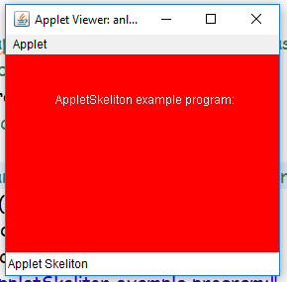

**Aim:** Write a java program that displays frames and 4 gui controls (Label, Button, TextArea, checkbox) using AWT.

importjava.awt.*;

importjava.awt.event.*;

public class ItemListen extends Frame implements ItemListener {

Label label1, label2; Checkbox c1,c2,c3,c4,c5; CheckboxGroup group;

publicItemListen(){

setVisible(true);setSize(300,300); setBackground(Color.RED);

setForeground(Color.WHITE);

setLayout(new FlowLayout()); setTitle("MyCheckbox Demo");

label1=new Label("Qualification: "); label2=new Label("Gender");

c1=new Checkbox("10th"); c2=new Checkbox("Inter");

c3=new Checkbox("B.Tech"); c1.addItemListener(this);

c2.addItemListener(this); c3.addItemListener(this);

group=new CheckboxGroup();

c4=new Checkbox("male",group, true);

c5=new Checkbox("female",group, false);

c4.addItemListener(this); c5.addItemListener(this);

add(label1); add(c1);add(c2); add(c3);

add(label2); add(c4);add(c5);

this.addWindowListener(new WindowAdapter() {

public void windowClosing(WindowEvent we){

System.exit(0);

}

});

}

public static void main(String[] args) {

ItemListenitemListen=new ItemListen();

}

String qual="",gender="";

@Override

public void itemStateChanged(ItemEvent arg0) {

if(c1.getState()==true){

qual=qual+c1.getLabel();

}

if(c2.getState()==true){

qual=qual+c2.getLabel();

}

if(c3.getState()==true){

qual=qual+c3.getLabel();

}

if(c4.getState()==true){

gender=gender+c4.getLabel();

}

if(c5.getState()==true){

gender=gender+c5.getLabel();

}

repaint();

}

public void paint(Graphics graphics){

graphics.drawString(qual, 50, 200);

graphics.drawString(gender, 50, 250);qual="";

}

}

**Output:**

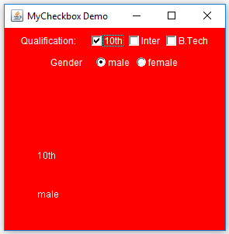

**Aim:** Write a java program that displays menu and menu items using AWT

importjava.awt.*;

importjava.awt.event.*;

public class MenuItems extends Frame implements ActionListener{

MenuBar bar; Menu m1,m2,m3; MenuItem i1,i2,i3,i4;

publicMenuItems(){

setVisible(true); setSize(300,300); setBackground(Color.RED);

setForeground(Color.WHITE); setLayout(new FlowLayout());

addWindowListener(new WindowAdapter() {

public void windowClosing(WindowEvent arg0) {

System.exit(0);

}

});

bar=new MenuBar(); setMenuBar(bar);

m1=new Menu("File");m2=new Menu("edit");m3=new Menu("Help");

bar.add(m1); bar.add(m2);bar.add(m3);

i1= new MenuItem("save");i2= new MenuItem("open");

i3= new MenuItem("cut"); i4= new MenuItem("paste");

m1.add(i1);m1.add(i2); m2.add(i3);m2.add(i4);

i1.addActionListener(this);i2.addActionListener(this);i3.addActionListener(this);

i4.addActionListener(this);

}

public static void main(String[] args) {

MenuItemsmI=new MenuItems();

}

String status="";

public void actionPerformed(ActionEvent arg0) {

status=arg0.getActionCommand(); repaint();

}

public void paint(Graphics graphics){

graphics.drawString(status, 50, 200);

}

}

**Output:**

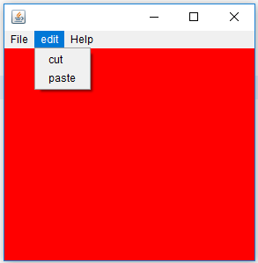

**Aim:** Write a java program that displays Jframe and 4 GUI controls using Swings.

**import**java.awt.FlowLayout;

**import**javax.swing.*;

**public class** MySwing **extends** JFrame{

JLabel lb1,lb2,lb3;

JButton but1,but2;

JTextField jf1,jf2;

JRadioButton rb1,rb2;

**public**MySwing() {

setVisible(**true**); setSize(350, 400);

setTitle("Swing Example");

setDefaultCloseOperation(JFrame.***EXIT_ON_CLOSE***);

lb1=**new**JLabel("username"); lb2=**new**JLabel("password");

jf1=**new**JTextField(12);

jf2=**new**JTextField(12);

lb3=**new**JLabel("gender");

rb1=**new**JRadioButton("male",**false**);

rb2=**new**JRadioButton("female",**false**);

but1= **new**JButton("ok "); but2= **new**JButton("cancel");

setLayout(**new**FlowLayout());

add(lb1); add(jf1); add(lb2); add(jf2); add(lb3);

add(rb1);add(rb2);

add(but1); add(but2);

}

**publicstaticvoid** main(String[] a){

MySwingms=**new**MySwing();

}

}

**Output:**

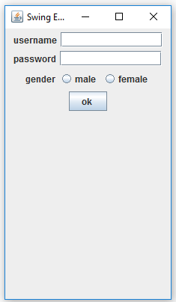

**Aim:** A java program for implementing Graphics

**Code:**

/*<applet code="GraphicsDemo.class" width="300" height="300">

</applet>  */

import java.applet.Applet;

import java.awt.*;

public class GraphicsDemo extends Applet{

public void paint(Graphics g){

g.setColor(Color.red);

g.drawString("Welcome",50, 50);

g.drawLine(20,30,20,300);

g.drawRect(70,100,30,30);

g.fillRect(170,100,30,30);

g.drawOval(70,200,30,30);

g.setColor(Color.pink);

g.fillOval(170,200,30,30);

g.drawArc(90,150,30,30,30,270);

g.fillArc(270,150,30,30,0,180);

}

}

**Output:**

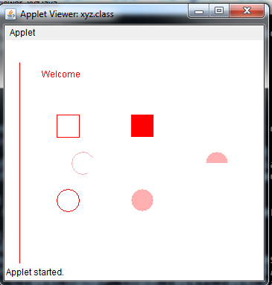

**Aim**: A java program to implement font and colors.

**Code:**

import java.applet.Applet;

import java.awt.*;

import java.awt.event.*;

/* <APPLET CODE ="FontClass.class" WIDTH=300 HEIGHT=200> </APPLET> */

public class FontClass extends java.applet.Applet

{

        Font f;

        String m;

          public void init()

             {

                 f=new Font("Arial",Font.ITALIC,20);

                 m="Welcome to Java";

                 setFont(f);

             }

            public void paint(Graphics g)

            {

                          Color c=new Color(0,255,0);

                          g.setColor(c);

                         g.drawString(m,4,20);

             }

  }

**Output:**

[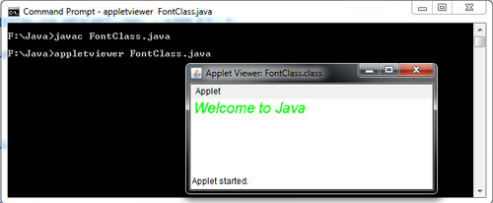](http://ecomputernotes.com/images/FontClass.jpg)